

Event zone

PROJECT INTRODUCTION

**Project code: EZ**

**Document code: EZ_ProjectIntroduction_1.2**

Record of change

*A - Added　M – Modified　D – Deleted

|  |  |  |  |  |
| --- | --- | --- | --- | --- |
| Effective Date | Changed Item | A*M, D | Change Description | Revision Number |
| 13/09/2015 | Create new | A | Create document | 1.0 |
| 19/09/2015 | Update | M | Fix Grammar  Change Background | 1.1 |
| 29/09/2015 | Update | M | Change Background | 1.2 |

Contents

**1.** **Purpose** 4

**2.** **Project Information** 4

**3.** **Project members** 4

3.1 Supervisor 4

3.2 Team Member 4

**4.** **Background** 5

4.1 What is an event? 5

4.2 Is the events industry growing? 6

4.3 Event industry landscape in Viet Nam 7

4.4 Event’s Marketing trends in 2015 7

4.5 Why live streaming? 9

**5.** **Literature Review of Existing System** 9

5.1 sukienhay.com 10

5.2 talktv.vn 10

5.3 eventbrite.com 11

5.4 Livestream.com 12

**6.** **Proposal of our system** 13

6.1 Our proposal system 13

6.2 Introduction about of proposal system 16

# **Purpose**

This document provides an overview of Event Zone including background information, literature review of existing system and raise a proposal for ideas of improvement.

# **Project Information**

* Project name: Event Zone
* Project code: EZ
* Project group name : EZ Team
* Product type: Website Application
* Timeline: From 7th September 2015 to 19th December 2015

# **Project members**

## **Supervisor**

|  |  |  |  |  |
| --- | --- | --- | --- | --- |
|  | Full name | Phone | E-Mail | Title |
| Supervisor | Trần Bình Dương | 0936168165 | [DuongTB@fpt.edu.vn](mailto:DuongTB@fpt.edu.vn) | Lecturer |

*Table 1.1: Supervisor information*

## **Team Member**

|  |  |  |  |  |  |
| --- | --- | --- | --- | --- | --- |
|  | Full name | Student code | Phone | E-mail | Role in Group |
| 1 | Phan Thanh Vũ | SE61276 | 01689241500 | [VuPTSE61276@fpt.edu.vn](mailto:VuPTSE61276@fpt.edu.vn) | Leader |
| 2 | Dương Thị Lan Anh | SE02721 | 01678388747 | [AnhDTLSE02721@fpt.edu.vn](mailto:AnhDTLSE02721@fpt.edu.vn) | Member |
| 3 | Nguyễn Thị Chương | SE02649 | 01673225638 | [ChuongNTSE02649@fpt.edu.vn](mailto:ChuongNTSE02649@fpt.edu.vn) | Member |
| 4 | Nguyễn Văn Cường | SE02837 | 01687388281 | [CuongNVSE02837@fpt.edu.vn](mailto:CuongNVSE02837@fpt.edu.vn) | Member |
| 5 | Nguyễn Sen Hà | SE02665 | 01644699884 | [HaNSSE02665@fpt.edu.vn](mailto:HaNSSE02665@fpt.edu.vn) | Member |
| 6 | Nguyễn Ngọc Dương | SE02205 | 01668094399 | [DuongNNSE02205@fpt.edu.vn](mailto:DuongNNSE02205@fpt.edu.vn) | Member |

*Table 1-2: Team members’ information*

# **Background**

## **4.1 What is an event?**

An event can be defined as any public gathering of people for a purpose. The events industry can be divided into three main sectors, based along content lines:

* Sport
* Meetings/Conference/Expos (Business)
* Cultural /Arts/Music

Events are staged both for profit and non-profit, by business, government or community. Events can be held for commercial, celebratory, entertainment or specific reasons and or causes.

## **4.2 Is the events industry growing?**

Event Management is one of the fastest growing industries in all over the world. Event Management includes management of personal events, leisure events, cultural events, religious events, corporate or organization events. The special events industry has grown enormously in the last two decades. According to recent research conducted by Joe Goldblatt, Certified Special Events Professional (CSEP), annual spending for special events worldwide is estimated at $500 billion[1].

Optimism and opportunity are both clearly in the air amongst event professionals, as 66% say they’re expecting their existing events to grow (versus just 4% who expect them to decline); and over half of the organizers in our survey are expecting to launch more events in 2015 (with just 5% saying they’ll run less)[2].

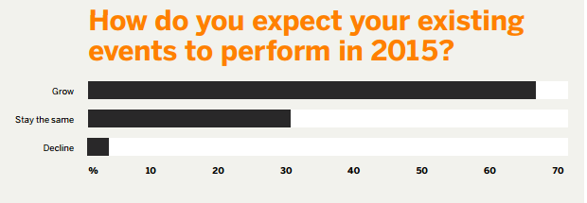

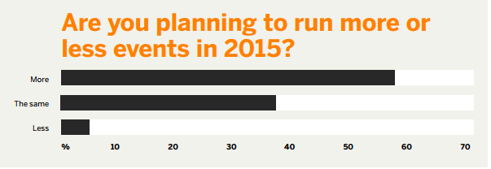

## 4.3 **Event industry landscape in Viet Nam**

According to initial estimates of the FTA market research organization, each year in Vietnam thousands of events be held. Average annual spending more businesses $ 15 billion in various events such as customer conference, introduced showroom (Data source of market research FTA)

Event industry is growing rapidly with an estimated 30% of new companies are appearing on the market, there are now more than 20 professional events organizing companies and hundreds of advertising business companies activities together with event services, so the number of companies increasing event is a good sign for the Vietnam event market.

🡪 Event demand in Vietnam is increasing rapidly.

## **4.4 Event’s marketing trends in 2015**

According survey of Eventbrite[3], we have following statistic:

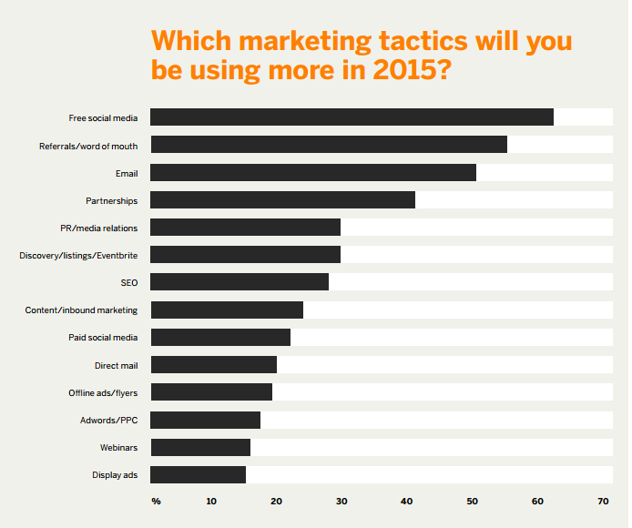

A huge 64% of all organizers taking the survey said they planning to use more social media marketing in 2015 – great news for the mobile apps, websites and software out there that help organizations to manage their social media marketing.

* By seeing the trending of event planning and event PR in Vietnam and all over the world is exploding, the idea of creating a social media website which is specifically manage events, in order to decrease the gap between event planner and interested people is a good idea and has bright prospects. In specific, our team will build an event website which helps viewers easily search and follow event's information, while event planner can easily PR to get more viewers. In order to increase interactions and the effective of website, we will build the function Live Streaming as the highlighted functions and it is really attractive.

## **Why live event streaming?**

* The amount of time spent watching live video through on-line publishers has increased 648% to more than 1.4 billion minutes in the 2010[4]
* Potential market.
* Low cost high efficient: Since the cost for live streaming continue to drop, it’s easier for building (bandwidth, storage, infrastructures…) a live streaming than TV or other social media. It’s also attractive viewers because nowadays internet more popular than TV.
* More interaction with customers: while watching streaming, customer can chat, comment to current video streaming so they can interact with others. It make customers feel like that they are joined that event.
* It’s simple: It’s take only about 20 minutes to set up and streaming for the first time. And can watch instantly. So customers will feel more convenient and welcome to use it.

Aside from these benefits, live streaming provides a sense of excitement for your audience. The live stream itself is inherently about community. It makes your customers feel inclusive and exclusive simultaneously.

# **Literature Review of Existing System**

By reviewing some events and live streaming website, we already have gotten main details of those:

## **5.1 sukienhay.com**



* Scope of website: Events in Vietnam
* Provide almost functions that user need:
  + Can search, create, view, comment, vote or report an event
  + Create organization
  + Create and view blog.
  + Manage tickets of events: Give free tickets, book tickets, reserve seats.
  + Share to social networks
  + Manage events schedule based on Google Calendar
  + Pay online with Baokim
  + Huge popularity.
* Advantages:
  + Manage events
  + Location Search
  + Notification

## **5.2 talktv.vn**



* A streaming website.
* Scope: In Vietnam
* Focus on game, idol, movie streaming
* Functions:
  + Read news
  + Search videos
  + Share watching videos
  + Free with some function
* Advantage:
  + Streaming Video using tool
  + Have app for mobile

## **5.3 eventbrite.com**



* An event website
* Scope: the world
* Functions:
  + Search and view all events all over the world.
  + Search event by location with suggesting
  + Allow user to register and manage their own event.
  + Allow to promote their event by inviting others.
  + Have tools to reach new audiences, connect with social network.
  + Manage tickets, discount, sale by phone or website
  + Free for events which are publishing information on website, charge fee if having tickets.

## **5.4 Livestream.com**



* A streaming website
* Scope: the world
* Function:
  + Allow user to view live streams of events all over the world.
  + Allow user to create live streams of their own.
  + Charge fees.
  + Support user to streaming
  + Analytic hottest and most-viewed streaming
  + Allow user to follow other users
  + Event Facebook Application
  + Password Protected Event
  + Disable Viewer Count, Chat and Commenting

# **Proposal of our system**

## **6.1 Our proposal system**

After reviewing those characteristics of websites, they have their own advantages and disadvantages, so we came to an agreement about which functions our website should support to inherit their strong points and reduce their limitations:

***Function and feature to be implemented:***

For User:

* Log In, Log Out, Register, Forgot Password: User can register to use all functions of the website
* Search by Text or by Location: In order to look up for event, user not only can search by text as name, event creator,… they also can search by location of the event. The location of event will display in a map for additional purpose.
* Manage Event: Registered can manage their own event on our website. Each user has their own channel to create new events, edit or delete them. In creating events, they can create live streaming events, or upload videos for people to watch
* Interact in Event: Like, Share, Comment: Registered user can like any events, share them on other social networks, or comment as review in the event page
* Follow Event: In case users want to update any new information of the event they like, they can follow to have notifications when events are updated.
* Follow Category: Event Zone will provide function follow each category to orientate users to notice the events in the category they follow in front page.
* Manage Profile: Users can edit their basic information and their channel information.
* View Statistic: Event Zone provide information of: total likes, total views… of each events or all events for users to manage their channel better
* Report Violated Events: If users see events violated any cultural behaviors, or copyrights, they can report those events for Event Zone.
* Appeal Violation Reports: If an event was report wrongly and suffered from locking, users can appeal to unlock the event.

For moderators: Moderators are responsible for contents in Event Zone

* Lock/ Unlock Events: Moderators can lock any violated events or unlock any locked events
* Manage Violation Reports: Moderators can see violation reports to consider locking any events
* View Statistic: Event Zone provide information of: total likes, total views… of each events or all events.
* Manage Event: Moderators can also manage their own events as these events are registered to Event Zone

***Out-of-scope:***

* Making List Events: An user can make lists from their own events for viewers find them easily.
* Streaming Server: Because of difficulties in server and bandwidth, we choose Youtube as Streaming Server
* Upload Image: Viewers can upload image as contribution to the events
* View Schedule: Users can manage schedule of their following events.
* Follow Other Users: Users can follow others to have notifications anytime a new event is built.

|  |  |  |  |  |  |
| --- | --- | --- | --- | --- | --- |
|  | sukienhay.com | talktv.vn | eventbrite.com | livestream.com | EventZone |
| Create Event | X |  | X | X | X |
| Edit Event | X |  | X | X | X |
| Invite Others | X |  | X |  |  |
| View Blog | X |  |  |  |  |
| Search by Location | X |  | X |  | X |
| Manage Tickets | X |  | X |  |  |
| Like | X | X | X | X | X |
| Share | X | X | X | X | X |
| Comment | X | X | X | X | X |
| Follow Events | X |  | X |  | X |
| Follow Category |  |  |  |  | X |
| Report Violated | X |  | X | X | X |
| Appeal |  |  | X |  | X |
| Live Streaming |  | X |  | X | X |
| Analytic Event |  |  | X | X | X |

Finally, we use some new approaches to solve the problems stated. Having aware of the emergence of new technologies, we aim at applying them to our project.

## **6.2 Introduction about of proposal system**

The core idea of the system is making connection between event managers and event viewers to easier than ever. The information is completely made by user and process by system. Users who want to promote their event to more and more people can register their event here and make a space to for everyone to come and build up information. They can also live streaming their event for people who can’t come to watch online. Users who want to view event can search on their location to find the best fit event for them or search by name. They can also interact with others viewers by like, comment or share their watching events.

1. <http://www.lit.ie/BusAndHum/AppliedSocialSciences/Courses/26/event_management/EventsIndustry.html>
2. <http://www.eventbrite.co.uk/blog/event-industry-statistics-pulse-report/>
3. Event industry insights [2015](http://www.eventbrite.co.uk/blog/event-industry-statistics-pulse-report/)
4. <http://www.comscore.com/Insights/Blog/Live-Streaming-Video-Jumps-600-in-Past-Year>